/\* Ashok

Subreports and Drillthrough Lab

6.10.19 \*/

1….

SSRS Dashboard Design view

All 6 Reports in one report with help of subreport…

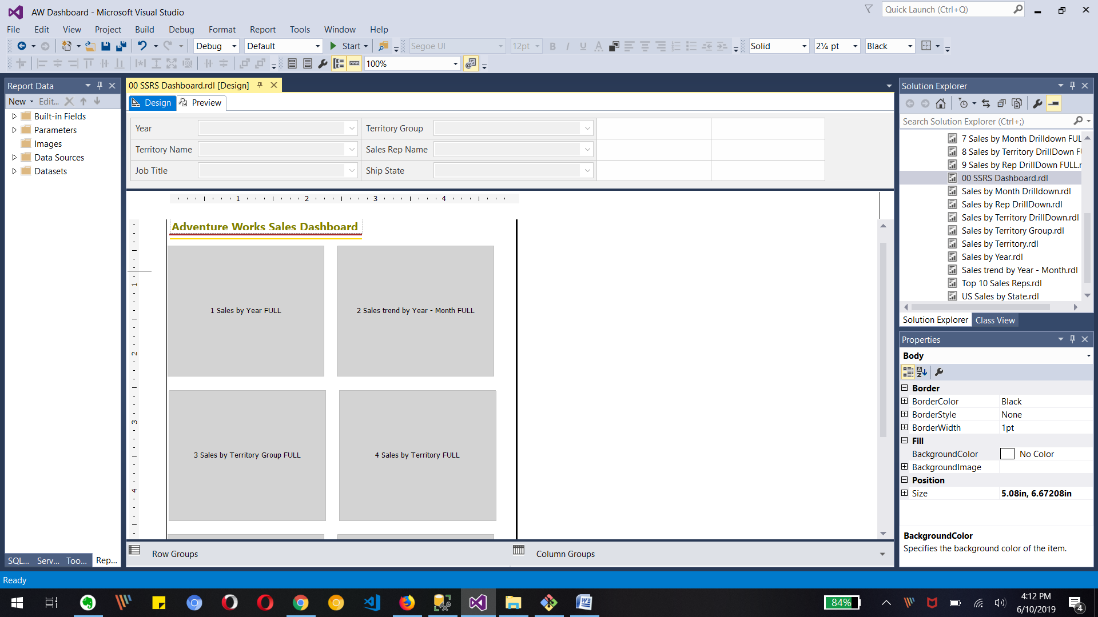

Final DASHBOARD PREVIEW with all 6 report together in one page for parameters values as below.

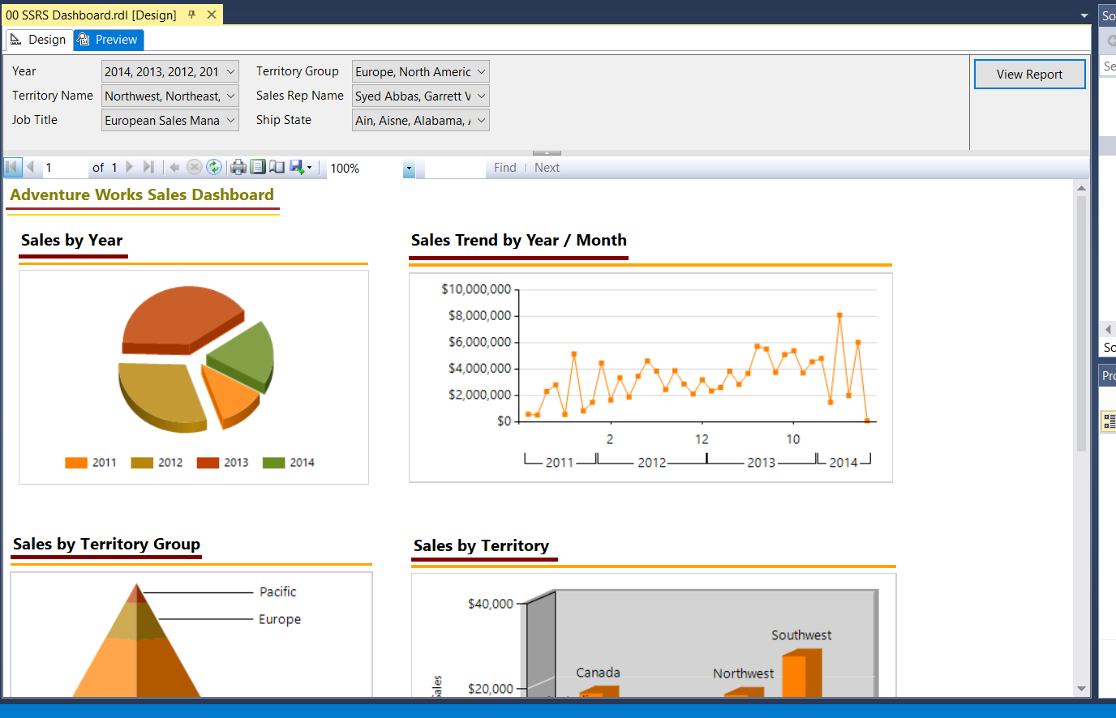

PAGE 1 Shows above image ,,,, Page 2 Shows below image

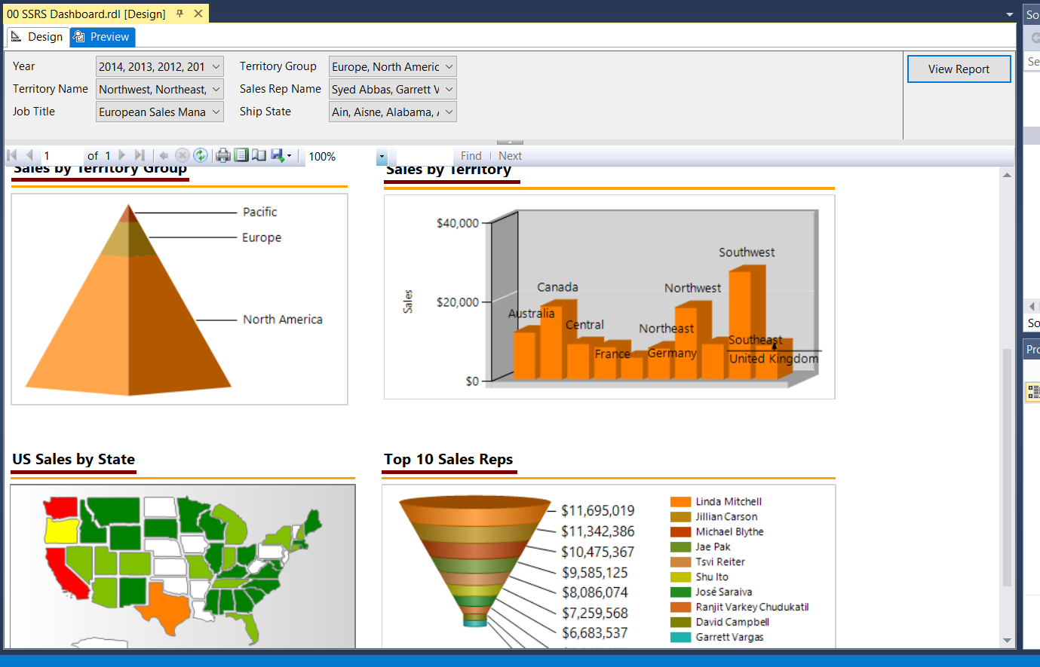

Now lets change the parameters so we can see how our dashboard get changed

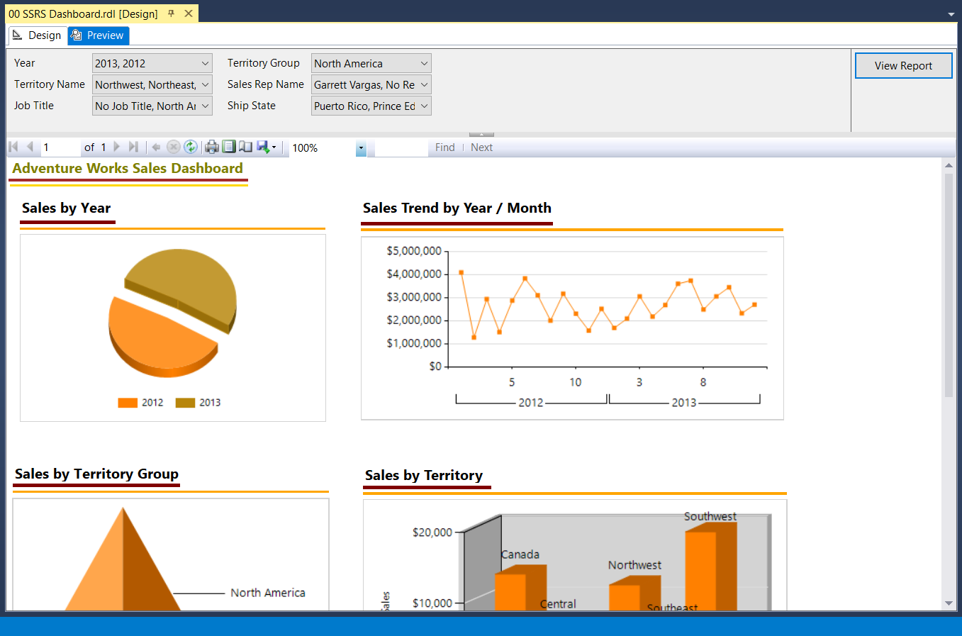

The above image shows that if we change parameters value/ selection then all 6 reports gets changed as per it.

Here we have year as 2013 and 2012 for North America Territory group, so there are changes in other charts.

Drillthrough for 3 different reports

1… Sales by Year Drillthrough

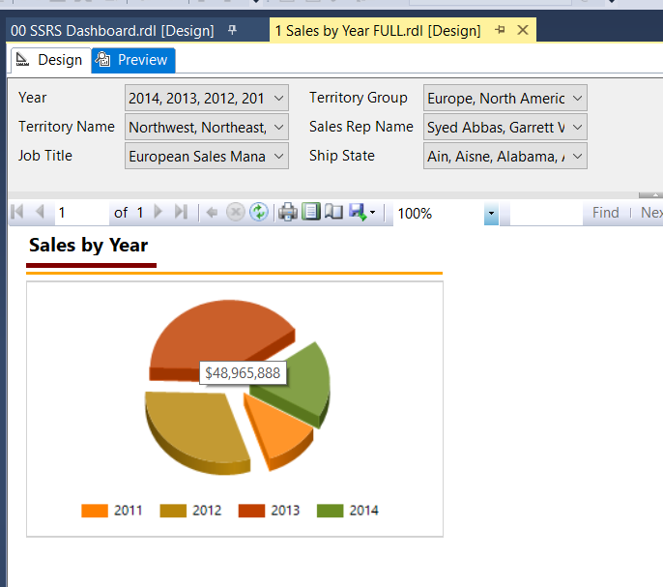

The above chare is for Sales by Year and cursor is on 2013 record so its shows tooltip as SumofTotalDue.

Now if we click on that part then it will bring us to Drilldown report for that year as below image.

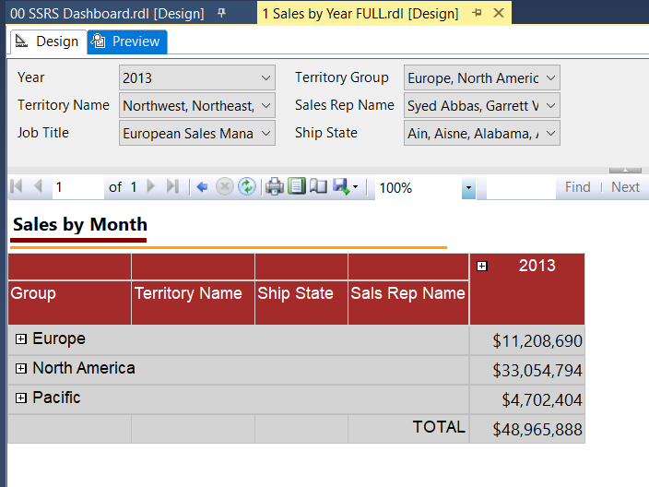

The above report is drilldown from Sales by Year report. I clicked on 2013 show it shows 2013 related data in above chart and we can see the parameter has value of 2013 only.

2… Sales by Territory Drillthrough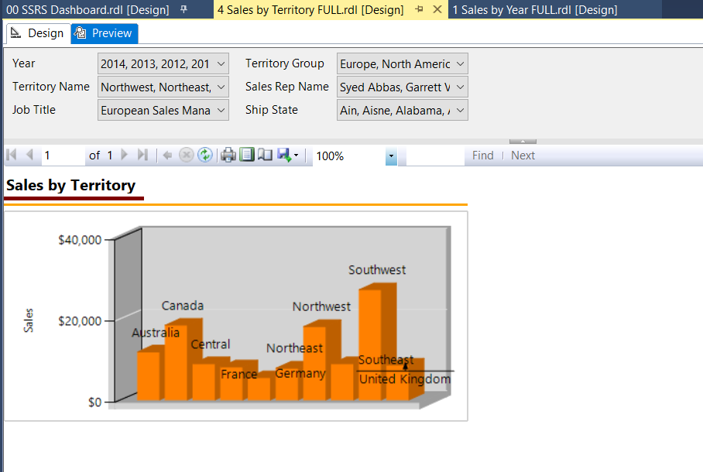

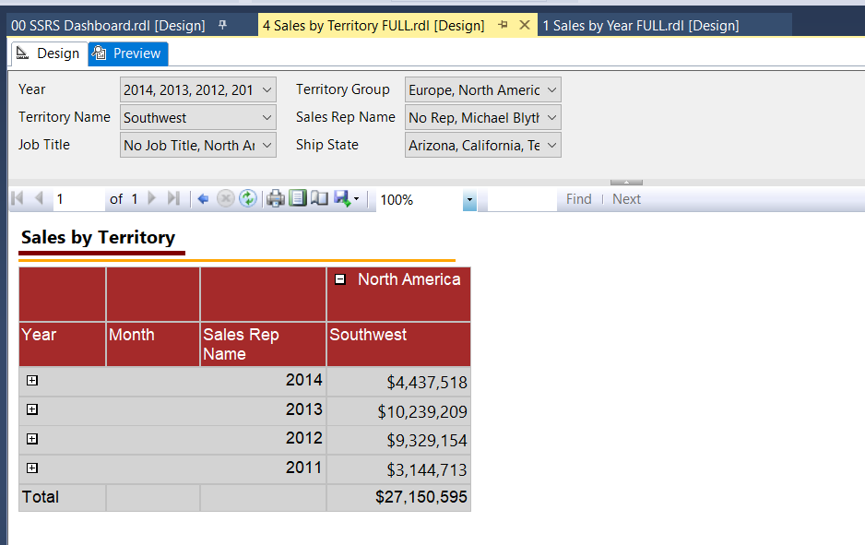

The above image shows the drilldown of Sales by Territory and I clicked on Southwest text that brings us to drilldown chart for Southwest territory with other data in chart. Also we can see the parameter for Territory is shown Southwest.

3.. Sales by reps Drillthrough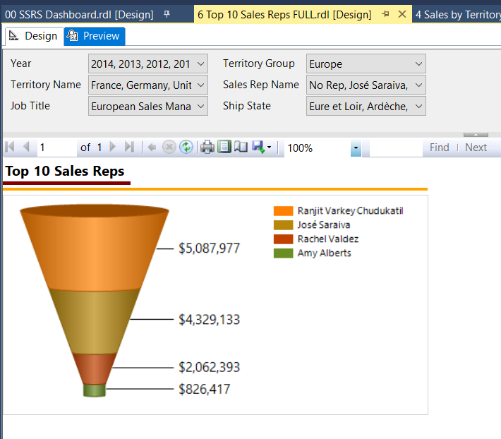

The above image is for Europe Territory Group only for its sales rep data. Now let’s click on any JOSE Saraiva Sales rep data to get more detail in drilldown report of him. Below drilldown is for Jose Sales Rep as we can see Sales rep Name parameter value and also in actual chart we see that name as sales Rep.

